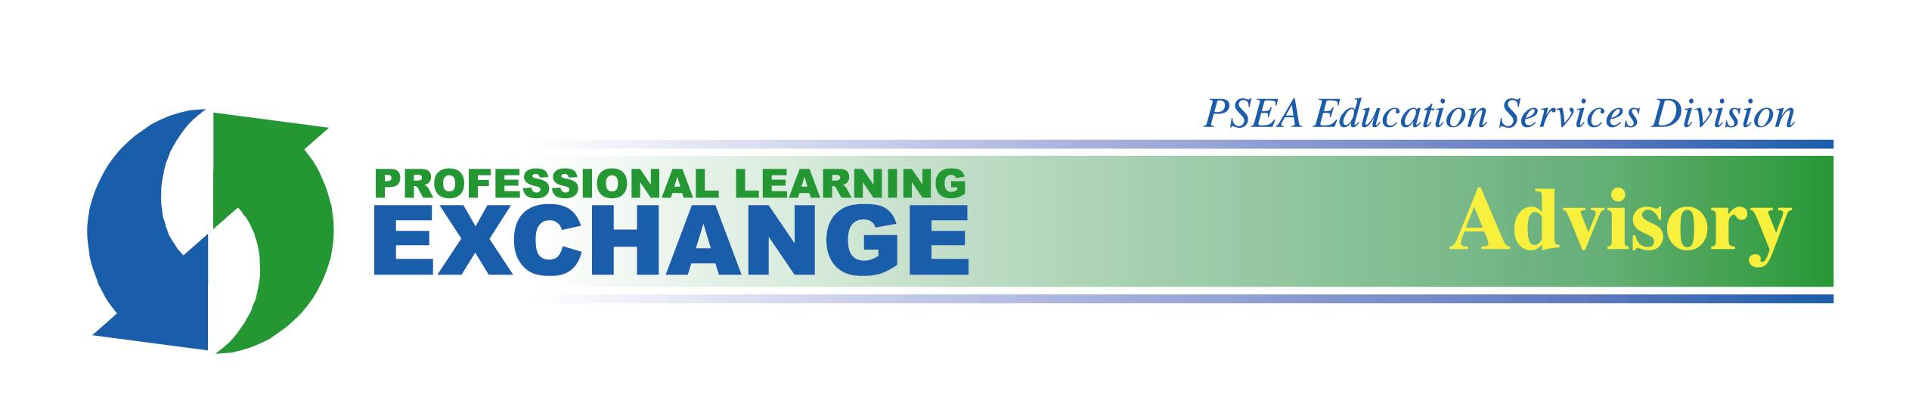

May 2019
Changes to the Furlough Process for Professional Employees

On Nov. 6, 2017, HB 178 was enacted into law as Act 55 of 2017. Act 55 amends the school code to: 1) add a new basis for the furlough of professional employees by school entities; and 2) change the rules associated with the order in which professional employees are furloughed. In the past, furloughs could be based only on a decrease in pupil enrollment, the curtailment or alteration of an educational program, or the consolidation or reorganization of schools. Now, furloughs can also be based on a school entity’s economic need. In addition, furlough decisions under the previous law were based solely upon employees’ seniority; now, furlough decisions are based upon a combination of employees’ seniority and performance evaluation results.

The new provisions become effective immediately unless a collective bargaining agreement explicitly addresses the manner in which employees will be furloughed, in which case Act 55 applies on the date of contract expiration. If a collective bargaining agreement incorporates the School Code by reference, then the new provisions are effective immediately.

PSEA opposes these changes to the furlough process and will continue to defend members’ rights within the new system. Local associations, however, cannot bargain contract language that is inconsistent with the new law.

What the New Law Says
As in the past, when a school entity decides to implement furloughs for one of the reasons listed above, temporary professional employees are the first educators to face furlough. Among professional employees, Act 55 places each educator into one of four categories based upon evaluation results from an employee’s last two consecutive evaluations. Within each of these four categories, furlough decisions are based upon seniority within the certificated area of an educator’s current assignment.

Figure 1 displays the four evaluation categories defined in the new law.

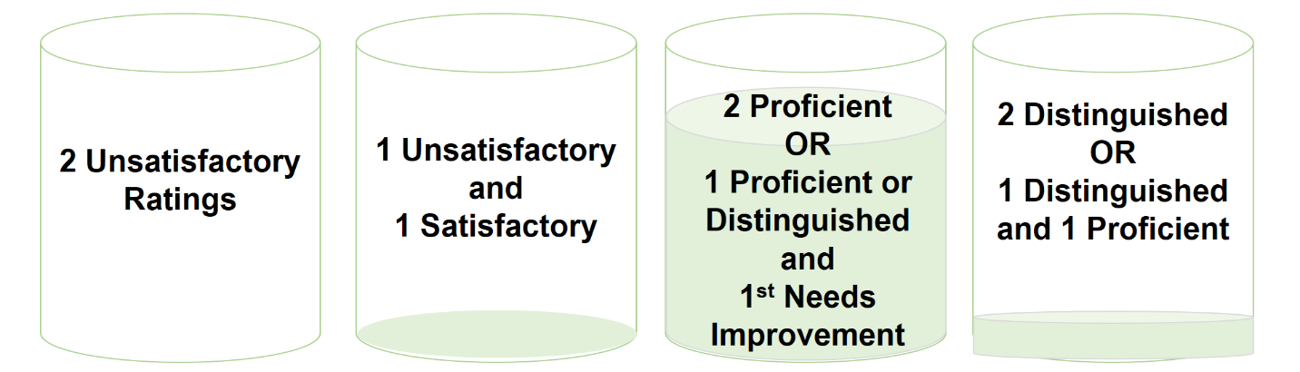
Figure 1: Professional Employee Evaluation Categories for Furlough within Certificated Area of Current Assignment
Fourth Category
Third Category
Second Category
First Category

In practical terms, the new law does not change the status of temporary professional employees (who will continue to be the first to face furlough) or professional employees with two unsatisfactory ratings (who may face dismissal under the School Code). The greatest impact of the law will be on professional employees who have received one unsatisfactory rating within their last two consecutive ratings. These employees will fall into Category 2 and be furloughed before their peers who have two satisfactory ratings in Category 3. Additionally, employees in Category 3 will be furloughed before their peers in Category 4.

In this new system, the vast majority of professional employees are contained within the same category (Category 3). Therefore, most PSEA members facing furlough will continue to be furloughed by seniority within their certificated area of assignment. The new law eliminates further realignment. This means that professional employees who are identified for furlough will not be able to use dual certificates to realign into other program areas to displace less senior professional employees. In addition, unions are no longer able to bargain for “checkerboarding” realignment, where professional employees who are more senior and hold dual certificates, but who themselves are not identified for furlough, are forced to move into those other areas of certification so that ultimately the least senior person in any program area is furloughed.

Professional employees still will be able to use any valid certificate for recall purposes, and recall from categories will occur in reverse order (i.e., Category 4, 3, 2, and then 1).

How the New Law Developed and Passed
For several years, a group of Pennsylvania legislators has been working to eradicate seniority-based furlough in favor of a system based upon specific measures of educator quality. PSEA has consistently argued that existing measures of educator quality are neither sufficiently valid nor reliable to rank educators for furlough decisions, and we have opposed efforts to move toward evaluation-based furloughs through lobbying and member activation. HB 178 presented a particular challenge, however, because it tied evaluation-based furlough to broader School Code provisions addressing other badly needed reforms and school funding. This meant that a vote against the bill or a veto would also kill items such as a school funding mechanism, mandatory school board training, opioid abuse education, a delay in the use of the Keystone Exams as a graduation requirement, and $14 million of support to public schools in Erie. Tying furlough changes to other legislative priorities in HB 178 meant that some legislators voted for the bill in support of these other reforms even though they were not inclined to support this change in furloughs.

Recognizing that HB 178 stood a good chance at passing into law, PSEA continued to strongly oppose the bill while simultaneously working with allies to soften its potential impact. Thousands of PSEA members, pro-public education lawmakers, and Gov. Tom Wolf advocated for important protections for educators in the bill before its passage.

Protections Negotiated into the New Law
PSEA opposes the new furlough law because it uses evaluation data that was never designed to rank teachers for any purpose, including furlough. However, the legislation does include some protections to help mitigate its impact.

First, the four categories defined by the law were constructed so that a substantial majority of professional employees fit into one category (Category 3), as mentioned above. Within this category, furlough decisions are based upon seniority and certification area. This means that for the vast majority of professional employees the primary furlough criteria will be seniority within the employee’s certificated area of work.

Second, if the furlough is based upon economic need, a school district is required to adopt a resolution stating its intention to furlough 60 days prior to the final passage of its budget. The district also must hold a public meeting in which it provides information to the public in several areas:

- The reasons that furloughs are necessary
- The total cost savings of the furloughs and other cost-saving measures being employed
- The number and percent of educators and administrators to be furloughed, the impact of those furloughs on academic programs, and how the impact will be mitigated
- Projected expenditures for the following year with and without furloughs, and
- Projected revenues for the next fiscal year

This public meeting potentially provides an important venue for PSEA members to advocate for critical programs and staff positions to the school community.

Third, the law requires districts to furlough an equal percentage of teaching and administrative staff. Five district administrative positions are exempt from this requirement. A school district can apply for a waiver from the Pennsylvania Department of Education (PDE) and the State Board to furlough fewer administrative positions if the district can demonstrate that its operations are already streamlined or that additional administrative furloughs would harm stability and programs.

Finally, the legislation makes it illegal to target educators based on their years of experience or salary. School officials who target educators will be subject to discipline by PDE. PSEA intends to vigorously defend members who may be illegally targeted for furlough because of years of experience or salary.
Changes to the Law via HB 1448 – Omnibus School Code Bill
HB 1448, effective July 1, 2018, amends Act 55 related to furloughs of professional employees to require a school entity to realign its professional staff to provide more senior employees the opportunity to fill any positions in the school entity for which they are certificated and which are being filled by less senior employees, subject to the order of suspension set forth in Section 1125.1 of the School Code.

Implementation: Issues to Monitor
Act 55 of 2017 raises several additional questions and concerns that require careful monitoring and potential intervention during implementation. Key among them are the following four.

Ensuring Proper Application of the Law. Local associations facing furloughs will need to ensure that the furloughs are: 1) legally justified; and 2) conducted in the appropriate order. As in the past, local associations will need to request documentation regarding the employer’s purported reasons for furlough and should monitor the district’s compliance with the new notice provisions applicable to economic furloughs. The local association also must request sufficient information to review the order of furlough, including information about seniority and evaluations for affected educators.

Misusing the Evaluation System. Pennsylvania’s educator evaluation system was neither designed nor validated for ranking employees for the purposes of furlough. Score differences that determine whether an educator attains one rating or another may be as small as 1/100 of a point. PSEA will continue to monitor districts’ implementation of the evaluation system to ensure results are valid, reliable, and fair.

Deterring Educators from Seeking Positions Requiring Certain Certifications. Because the new law furloughs educators based on evaluation results and seniority working within specific certification areas, educators may have greater protections if they are working in certification areas with more employees rather than fewer. Likewise, pre-service teachers in preparation programs may determine that it is strategically wiser to earn only one certificate in a widely used area. PSEA will monitor any potential impact of the new law on teacher assignments and certifications.

Challenging Confidentiality of Employee Ratings. Employers are required to maintain confidentiality of employee rating results; this requirement is not negated in the new furlough law. While local association representatives must be privy to evaluation information in the event of furloughs, these leaders should take necessary precautions to maintain confidentiality. However, since employees facing furlough will be sorted into categories based upon evaluation results, an employee’s placement into a specific category may become known to others without the consent of the employee. PSEA will continue to defend an employee’s right to confidentiality in the evaluation system.

Conclusion
The Association will continue to work with its members and with policymakers during implementation to ensure that protections defined in statute are fully implemented. In addition, PSEA will continue to defend members against targeting for furlough, to ensure the evaluation system is administered in ways that reduce bias and increase validity, and to protect member confidentiality in the evaluation system.

For More Information
Contact Brad Hull, Ph.D., in PSEA’s Education Services Department, bhull@psea.org; 717-255-7108.

Because furlough decisions are usually made near the end of the school year, an employee’s evaluation for the current year will not yet be issued. In other words, if an employee is furloughed at the end of the 2017-18 school year, the relevant evaluations will be those for the 2015-16 and 2016-17 school years.
School districts must approve an annual budget by June 30 each year. Consequently, a school district is required to adopt a resolution and hold a public meeting before the end of April if it plans to furlough staff.

